CHAPTER 2

EXPERIMENTAL METHODS

**2.1 Materials**

The two principal fluorescent conjugated polymers used to prepare conjugated polymer nanoparticles (CPNs) in these studies were poly[(9,9-dioctylfluorenyl-2,7-diyl)-*co*-(1,4-benzo-{2,1',3}-thiadiazole)] (PFBT, MW 10,000, polydispersity 1.7), and poly[2-methoxy-5-(2'-ethyl-hexyloxy)-1,4-phenylene vinylene] (MEH-PPV, average MW 200,000, polydispersity 4.0), and were purchased from ADS Dyes, Inc. (Quebec, Canada). The fluorescent dye perylene red (Exalite 613) was purchased from Exciton (Dayton, OH). Polystyrene microspheres, and the fluorescent dye fluorescein were purchased from Life Technologies (Invitrogen, Grand Island, NY). The fluorescent dye Lucifer Yellow CH dipotassium salt (LY, 1 mg/mL in water), 3-aminopropyl-trimethoxysilane (APS, 97%), sodium hydroxide (SigmaUltra, minimum 98%), and solvents tetrahydrofuran (THF, anhydrous, inhibitor-free, 99.9%), and ethanol (200 proof, anhydrous, ≥99.5%) were purchased from Sigma-Aldrich (Milwaukee, WI). All materials were used without further purification.

**2.2** **Nanoparticle Preparation**

The method used to prepare fluorescent conjugated polymer nanoparticles is based on a previously described nano-precipitation method,{Szymanski, 2005 #42} adapted from Kurokawa and co-workers.{Kurokawa, 2001 #144} A stock solution of a given conjugated polymer was prepared at a concentration of 1000 ppm (mg/kg) in THF. The polymers were sufficiently dissolved by gentle agitation of the solution at room temperature. For these experiments, the precursor solution to the nanoparticle suspension was prepared by diluting an aliquot of stock solution to a concentration of 20 ppm. For doped samples, dopant fluorescent dyes or polymers were added into the solution in their respective amounts prior to the addition of the diluting solvent that. Typically, dopants were added so that their concentration in the diluted precursor solution was 0.1%–10% by weight, relative to the polymer concentration. The resulting solutions were agitated gently to ensure solution homogeneity. A 2 mL aliquot of precursor solution was then rapidly injected via micropipette into 8 mL of deionized water under bath sonication at a frequency of 40 kHz and room temperature for ~30 seconds.

It is a combination of the very dilute concentration of polymer, and fast injection of the precursor solution that result in nanoparticle formation. It is thermodynamically favorable for a hydrophobic, long-chained molecule like a conjugated polymer to aggregate with itself in water (a poor solvent). Indeed, this is a commonly utilized method of polymer purification.{Colborne, 1955 #145} By first dissolving the polymers into a good solvent that is also water-miscible such as THF, it is easier to incorporate the polymers into a poor, mostly aqueous environment, depending on the speed in which it is added. Adding the dissolved polymer into a poor solvent drop-wise results in increased aggregation of the hydrophobic polymer. This can be confirmed with our polymer samples, as vacuum filtration of a solution in which dissolved polymer is added drop-wise to rapidly mixing water results in the loss of >80% the polymer during the subsequent filtration step as confirmed by UV-Vis. It is by fast injection of the THF solution into rapidly mixing water that local polymer chain collapse occurs as a result of hydrophobic interactions, polymer-water interfacial tension, and surface free energy effects.{Yang, 2005 #55} Under these conditions, this occurs at a faster rate that does not allow for flocculation to occur before a given sample of polymer collapses and is moved from its local environment into the bulk solution. Thus, nanoparticle formation is the kinetically favored product of mixing dissolved polymer into a poor solvent. After nanoparticle formation occurs, the collapsed chain conformation is retained as the remaining THF is removed, resulting in an aqueous colloidal suspension of conjugated polymer nanoparticles. The size of the nanoparticles can be adjusted by increasing or decreasing the concentration of the precursor solution. For example, increasing the precursor concentration yields a concomitant increase in nanoparticle size.{Wu, 2007 #54} Typical mean particle sizes range from 4-30 nm, which is verified by atomic force microscope (AFM) image analysis.

The process by which THF was removed from the samples has been refined from our previous partial vacuum evaporation procedure. THF was removed by placing the nanoparticle samples in a vacuum oven at room temperature under nitrogen flow for 8-10 hours in order to remove enough THF to prevent bumping during the subsequent partial vacuum evaporation step. Nitrogen flow was ceased and samples were evaporated under vacuum for 6-7 hours at a temperature of ~40 °C to remove most of the remaining THF. The total volume of liquid was reduced by ~60% during the evaporation process, which was confirmed to be sufficient by an iterated Raoult’s Law calculation, the results of which yield that <1% THF exists at ~40% volume loss. No residual THF odor was detected in the samples. Additionally, further evaporation yielded no further change in the fluorescence spectrum or quantum yield. The samples were subsequently vacuum filtered through a glass fiber prefilter and a 0.1 µm PVDF membrane filter in order to remove larger aggregates. The resulting suspensions are clear (not turbid) and stable, showing no signs of aggregation for months.

**2.3 Characterization Methods**

Several techniques are employed in order to characterize our nanoparticle samples. These include atomic force microscopy (AFM), UV-Vis spectroscopy, steady-state fluorescence spectroscopy, and fluorescence quantum yield measurement.

**2.3.1 Atomic Force Microscopy (AFM)**

Nanoparticle size distributions are determined with an Ambios Q250 multimode AFM in intermittent contact (AC or tapping) mode. In all modes of AFM imaging, a cantilever with a sharp probe tip is raster-scanned across a sample immobilized on a glass coverslip or other substrate. In tapping mode, the cantilever is vibrated at a frequency close to the resonant frequency of the cantilever material (70-200 kHz), and at constant amplitude by a piezoelectric element on the AFM tip mount. As the cantilever is brought into proximity of a sample during the raster scan, the forces acting on the cantilever are dampened by the periodic contacts between the tip and the sample, reducing the amplitude of cantilever oscillations. The cantilever oscillations are monitored by a laser reflected off of the cantilever onto a quadrant photodiode detector. The probe height is adjusted by a separate piezoelectric element within the AFM head, and the changes in height are controlled by an electronic feedback loop coupled to the quadrant photodiode detector output. This works to restore the amplitude of the cantilever vibration once the oscillation amplitude moves above or below an adjustable set point amplitude. The image is produced line-by-line by translating the changes in probe height into a topographic image of the sample. Particle sizes are determined by analyzing the peak z-heights of each viable particle in the image and constructing a histogram to determine the mean and standard deviation of the particle sizes.

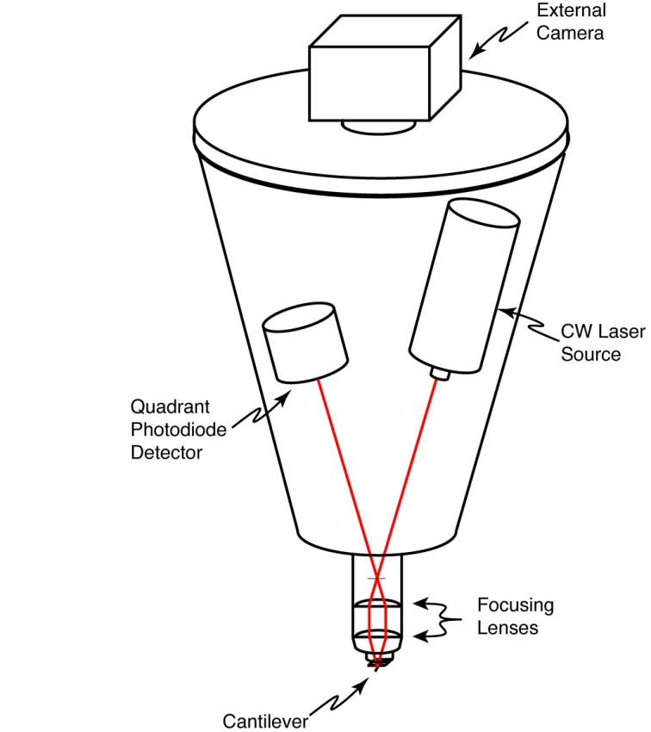

Fig. X. Simplified schematic of a typical AFM head.

AFM samples were prepared by a dip-casting procedure. First, a cleaned, dry glass coverslip was amine-functionalized with 70 µL of freshly prepared 5×10-4 M APS in anhydrous ethanol. The solution was left on the coverslip for 3 minutes, followed by rinsing the coverslip with deionized water, and blowing it dry with nitrogen. An aliquot of the nanoparticle suspension was diluted by 30-40 times in a small beaker, and the coverslip was submerged into the diluted suspension with the functionalized side up for 40 minutes. The coverslip was then carefully removed from the solution and allowed to dry completely in a vacuum oven at room temperature. To prepare the sample for AFM use, the coverslip was fixed to a glass slide with thin strips of tape.

There are several factors that impact the quality of an AFM image, including tip wear or breakage, as well as improper tuning of the PID (Proportional, Integral, and Differential) feedback loop. It is not possible to extract accurate particle size information from the diameters of the particles in the x-y plane due to tip convolution effects between the sample surface and the tip, which distort the image in the x-y plane. The sharper the tip is, the smaller this effect is. As the tip wears and becomes blunted, this convolution effect is exacerbated, making the particles appear larger in the x-y plane. If foreign matter (e.g. dust, dirt) is stuck to the tip, or the tip is broken as a result of crashing the tip into the sample substrate, this can yield false duplicate particles in the image (for every particle in the image). Improper setting of the PID feedback loop can result in cantilever hysteresis, in which the change in z-height needed to restore the cantilever oscillations to the set point value is overshot (or undershot) compared to the actual change required to restore the oscillations to the set point value. This translates into improper z-height values, and the potential to have the probe tip either scratch the sample or crash into the sample or substrate, damaging the probe tip.

**2.3.2 UV-Vis/Absorption and Fluorescence Spectroscopy**

UV-Vis absorption spectra were collected on a Shimadzu UV2101PC scanning spectrophotometer using 1 cm quartz cuvettes. The absorption spectra were used to determine the nanoparticle concentration and peak absorption wavelength corresponding to the HOMO-LUMO electronic transition. For fluorescence measurements, concentrated nanoparticle samples (peak absorbance between 0.2–0.4) were diluted to yield a peak absorbance of ~0.1 for collection of fluorescence spectra or fluorescence lifetime measurement. Extinction coefficients for each polymer in THF were calculated by rearranging Beer’s Law to give , where ** is the extinction coefficient of the polymer at a given wavelength, *A* is the absorbance of the sample, *l* is the sample path length (typically 1 cm) and *c* is the molar concentration of polymer. To calculate the nanoparticle extinction coefficient, the number of polymer molecules per nanoparticle *Nnp* is determined from the mean nanoparticle volume (determined from the mean radius from AFM measurements) and the polymer molecular weight, using the assumption that the polymer density is ~1 g/cm3. This is then multiplied by the extinction coefficient for the polymer in THF yielding . Samples were diluted to an absorbance of ~0.05 for fluorescence quantum yield measurement. Steady-state fluorescence spectra were collected using a commercial fluorescence spectrometer (Quantamaster, Photon Technology International, Inc.) with 1 cm cuvettes. Samples were diluted to an absorbance of ~0.1 AU or less at the relevant excitation wavelengths. To avoid saturation of the photomultiplier tube (PMT) detector, all slit widths were kept at 0.50 mm. The acquisition time was set to 1 s/nm to reduce noise in the spectra.

It is important to ensure sufficient dilution of fluorescent samples in order to avoid the inner filter effect, in which a photon emitted by one molecule is reabsorbed or scattered by another molecule in close proximity. An important note about the inner filter effect is that it is not limited by sample concentration alone in CPNs. Particle size must also be considered in this case, since it is possible to prepare nanoparticles with diameters that exceed the optical penetration depth of the material. The optical penetration depth (or optical skin depth) of a material can be determined by , where **(**) is the absorption coefficient of the material at wavelength **, *A*(**) is the absorbance at wavelength **, and *d* is the thickness of the material. Optical penetration depths range from tens of nanometers to several microns, depending on the material. Typical values for conjugated polymers range from ~40 nm to ~400 nm.{Yu, 2009 #146}{Bazani, 2009 #147}{Snaith, 2004 #165} Since CPNs are comprised of multiple closely-spaced chromophores, it is possible for a photon to be emitted from a chromophore on one end of a large particle, transmit through the particle, and be reabsorbed by another chromophore at the opposite end. This is one of the reasons why vacuum filtration is used to remove larger aggregates from the nanoparticle suspensions prior to measuring their fluorescence.

**2.3.3 Fluorescence Quantum Yield**

The fluorescence quantum yield (QY or PLQY) of the CPN samples was determined in several steps. First, an appropriate standard fluorophore must be selected with an absorption and emission maximum similar to the conjugated polymers under study. In this work, the standard fluorophores used were fluorescein dissolved in 0.01 M sodium hydroxide, and Lucifer Yellow CH dissolved in water (LY). A common absorption wavelength was selected between the sample and standard (473 nm for fluorescein, 450 nm for LY), and solutions were prepared at an absorbance of ~0.05 AU at the common absorption wavelength. Emission spectra were collected at the common excitation wavelength, and the fluorescence quantum yield is calculated by the expression

, (2.1)

where, *F*,*s* is the fluorescence quantum yield of the standards (0.92 for fluorescein in 0.01 M NaOH and 0.21 for LY),{Weber, 1957 #47}{Stewart, 1981 #93} *F,x* is the fluorescence quantum yield of the sample, *A* is the absorbance, *I* is the integrated fluorescence intensity, and *n* is the refractive index of the solvent. It is important to note that a solvent blank must be measured for both absorbance and fluorescence measurements in order to properly apply baseline correction to the spectra when calculating the fluorescence quantum yield.

**2.4 Picosecond Time-Correlated Single Photon Counting Spectroscopy (TCSPC)**

**2.4.1. Basic Instrument Operation**

Picosecond fluorescence lifetimes were measured under nitrogen using a home-built setup for time-correlated single photon counting (TCSPC) spectroscopy operating in either forward or reverse mode. Frequency doubled pulses (420 nm) from a passively mode-locked Ti:Sapphire laser (Coherent Mira 900, 840 nm pulses, ~150 fs pulsewidth) were used as the excitation source for the nanoparticle samples. Fluorescence was collected perpendicular to the excitation source and passed through a 460 nm long pass filter, and a calcite Glan-Taylor polarizer (Thorlabs, GT10-A) oriented at magic angle (55°) to the vertically polarized excitation pulses. For TCSPC measurement, the polarizer is oriented at 55° (magic angle) since the intensity decay collected at this orientation corresponds to the sum of the fluorescence intensity in the x, y, and z planes, given by , as previously discussed. The output of a single photon avalanche photodiode (APD, id Quantique, id100-50) was used as the start timing pulse for a time-to-amplitude converter (TAC, Canberra Model 2145), and the output of a fast PIN diode (Thorlabs, DET210) was used as the stop pulse, in a standard reverse-mode configuration.{Schaffer, 1999 #88;Cross, 1984 #87} In forward-mode TCSPC, the detector outputs to the TAC are switched. The excitation power was attenuated (between ~300 µW and 1 mW, typ.) to maintain a count rate of ~400 kHz as measured at the APD. The analog TAC output was digitized using a multi-channel analyzer (FastComTec, MCA-3A).

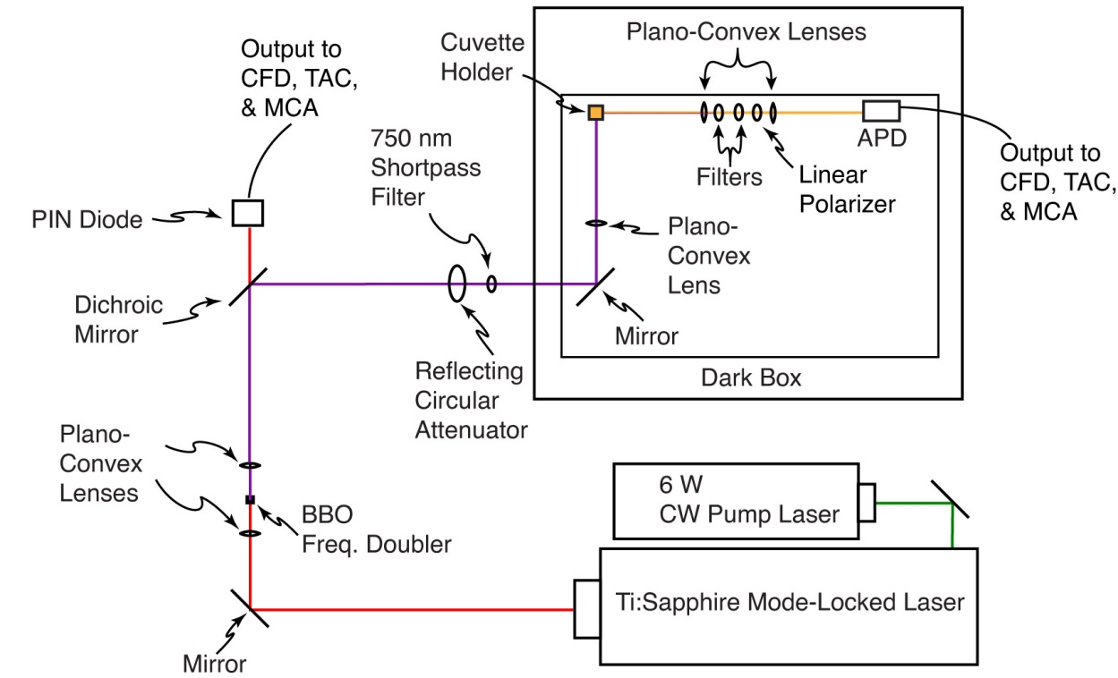

Fig. X. Time-Correlated Single Photon Counting and Fluorescence Anisotropy Decay setup.

Before and after each measurement an instrument response function (IRF) was measured using scattered excitation light from a dilute suspension of polystyrene microspheres. The width of the IRF was determined to be ~70 ps (fwhm). Typical peak signal-to-noise ratios (SNR) for each run were between 200:1-500:1 in reverse mode, and 50:1-100:1 in forward mode. Due to the random nature of photon arrival, the SNR is determined from the Poisson probability distribution function (PDF), given by

, (2.X)

Where ** is the mean of the distribution of photon arrival times and *N* is the number of photon arrival events. The SNR is approximated by the standard deviation of the distribution as  (e.g. 10,000 photon counts at the peak results in a peak SNR of 100:1).

**2.4.2 Validation of the TCSPC Instrument**

For the technique of time-correlated single photon counting (TCSPC), there are several sources of artifacts, including afterpulsing in detectors, stray reflections in the apparatus, improper triggering (e.g., triggering on a ring instead of on the principal pulse), and signal reflections and nonlinearities in the timing and readout electronics. As such, precautions must be taken to ensure that data being collected in these experiments is of the highest possible quality. The instrument was carefully aligned, and baffles were employed to minimize stray light. Discriminator levels were adjusted to minimize the width of the instrument response function and minimize ringing. Proper impedance matching was employed. While there is a slight ring apparent in results obtained for samples with lifetimes greater than ~2 ns (c.f. Fig 3 in main text), we have validated the accuracy of the instrument using several standard dyes, including fluorescein in 0.01 M NaOH (τ = 4.1 ns),{Sjöback, 1995 #1313} coumarin 6 in ethanol (τ = 2.5 ns),{Sun, 2011 #1314} and perylene red in THF (τ = 5.6 ns).{Al-Kaysi, 2006 #1309} All lifetimes measured were within 10% of the literature values, indicating that the ringing, while visible, has a negligible effect on the lifetime results obtained.

**2.5 Picosecond Fluorescence Anisotropy Decay (FAD)**

Fluorescence anisotropy decay (FAD) measurements were performed using the aforementioned TCSPC setup, with the addition of a calcite Glan-Taylor linear polarizer (Thorlabs GT-10A) placed after the filter set, and before the focusing lens. For fluorescence anisotropy decay measurement, intensity decays and IRFs were collected at all three polarizer orientations. Unlike TCSPC, the excitation power is attenuated once and then held constant rather than variably attenuated for each sample in order to avoid systematic deviations in the anisotropy signal due to inconsistent excitation power. The excitation power is selected so that the collected emission at each polarizer orientation yields a count rate between 200 kHz and 800 KHz as measured on the APD. Typically, the strongest emission is collected when the emission polarizer is parallel to the excitation. Details of the FAD least-squares fitting analysis will be given in Chapter 4.